Algorithms and Programming I
LAB 5

Example1:
1 2 3 4 5
1 2 3 4 5
1 2 3 4 5

for (int i = 1; i <= 3; i++) {
for (int j = 1; j <= 5; j++)
System.Console.Write(j + " ");
System.Console.WriteLine();
}

Example2:
******
******
******
******

for (int i = 1; i <= 4; i++) {
for (int j = 1; j <= 6; j++)
System.Console.Write("*");
System.Console.WriteLine();
}

Example3:
*
****
*******
**********
*************

int yildiz_sayisi = 1;

for (int i = 1; i <= 5; i++)
{
for (int j = 1; j <= yildiz_sayisi; j++)
System.Console.Write("*");

System.Console.WriteLine();
yildiz_sayisi = yildiz_sayisi + 3;
}

Example4:
*******
*****
***
*

int yildiz_sayisi = 7;
int bosluk_sayisi = 0;

for (int i = 1; i <= 4; i++)
{
for (int j = 1; j <=bosluk_sayisi; j++)
System.Console.Write(" ");

for (int j = 1; j <= yildiz_sayisi; j++)
System.Console.Write("*");

bosluk_sayisi = bosluk_sayisi +2;
yildiz_sayisi = yildiz_sayisi -2;
Console.WriteLine();
}

Exercises

Don’t use SetCursorPosition command in any question.

1- Write a program that prints the following output by using nested loops.
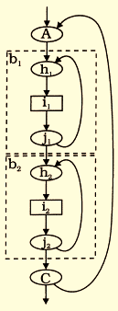
8 x 2 = 16
8 x 3 = 24
8 x 4 = 32
8 x 5 = 40
8 x 6 = 48
10 x 2 = 20
10 x 3 = 30
10 x 4 = 40
10 x 5 = 50
10 x 6 = 60
12 x 2 = 24
12 x 3 = 36
12 x 4 = 48
12 x 5 = 60
12 x 6 = 72

2- Write a program that prints the following song for up to 8 men using nested loops.

1 men went to mow, went to mow a meadow,
1 man and his dog, went to mow a meadow.

2 men went to mow, went to mow a meadow,
2 men,
1 man and his dog, went to mow a meadow.
3 men went to mow, went to mow a meadow,
3 men,
2 men,
1 man and his dog, went to mow a meadow.
4 men went to mow, went to mow a meadow,
4 men,
3 men,
2 men,
1 man and his dog, went to mow a meadow.
... etc

3-Write a program that takes an integer from the user and prints checkerboard pattern using nested loops.

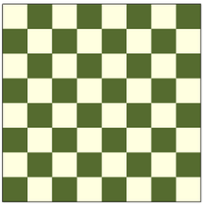
Examples:
Input: N = 4 Input: N = 5
Output: * * * * * * * * *
* * * * * * * * *
* * * * * * * * *
* * * * * * * * *
* * * * *

4- Write a program that prints the following shapes by using nested loops.

A
AB
ABC
ABCD
ABCDE

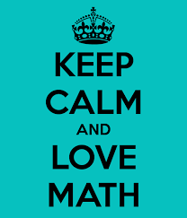
5- Write a program that takes the value of the x and number of terms from the user and prints the result.

term 1 term 2 term 3 term 4

6- Write a program that prints the following shapes by using nested loops.

1234554321
1234--4321
123----321
12------21
1--------1

7- Write a program that takes an integer n from the user and prints all possible combinations of three dices such that the sum of these dices is n.

Example:
Input: 5
Output: (1,1,3)
(1,2,2)
(1,3,1)
(2,1,2)
(2,2,1)
(3,1,1)

8- Write a program that prints the following shape using nested loops.
*** ***
*** ***
*** ***
*** ***
*** ***
*** ***
*** ***
******

9- Write a program that prints the following shape using nested loops.
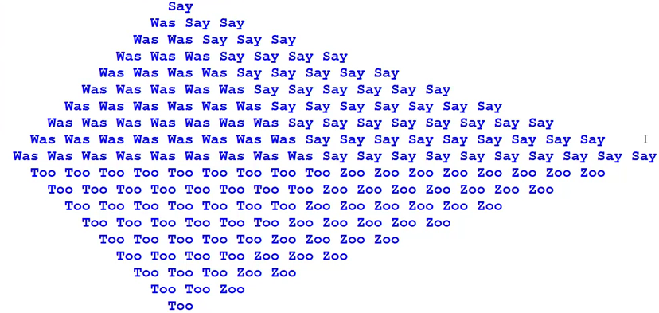

10- Write a program that prints the following shape using nested loops.
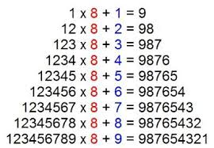
Questions

Upload the answers of the following questions from http://lectures.cs.deu.edu.tr/ web site until November 8, 2015.

1- Write a program that prints the following camel (in the sitting position) using nested loops.
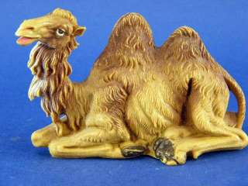
******* +++++ +
****** +++++++ +++++
***** +++++++++ +++++++++
**** +++++++++++ +++++++++++++
*** +++++++++++++ +++++++++++++++++
** +++++++++++++++ +++++++++++++++++++++
*++++++++++++++++++++++++++++++++++++++++++
*******************************************
**********************************************
*************************************************
****************************************************
*******************************************************

Don’t use SetCursorPosition command.

2- Write a C# program that prints the result of the following mathematical formula after 12 terms.

term 1 term 2 term 3 term 4

3- Write a program that takes month (integer), year (integer), first day (string) from the user and prints the calendar.

Examples:
Inputs: Month = 4  Year = 2015  First day = wednesday  Output:  April 2015  Mo Tu We Th Fr Sa Su  01 02 03 04 05  06 07 08 09 10 11 12  13 14 15 16 17 18 19  20 21 22 23 24 25 26  27 28 29 30 | Inputs: Month = 3  Year = 2012  First day = thursday  Output:  March 2012  Mo Tu We Th Fr Sa Su  01 02 03 04  05 06 07 08 09 10 11  12 13 14 15 16 17 18  19 20 21 22 23 24 25  26 27 28 29 30 31

Notes:
1- Don’t use SetCursorPosition command.
2- Don’t use Array data structure. If you use array, it will be graded with ZERO (0).

